3 Buttons as Brushstrokes

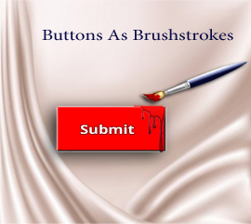

# What is a Button in Tkinter

Buttons in tkinter, are like putting a brush stroke onto the canvas. It begins a process; it starts a behavior. If you are an artist, this beginning brushstroke is your start to a stunning piece of art. But in the programming world, the button enables your program to become alive and do something. A button on a page all by itself will just sit there. But start to move the brush, and write the code, and watch it paint its picture, and do what it was born to do.

# Where do I get these buttons?

Well, you really don’t have to go far, as long as you know how to import the tkinter library, you have access to a button, and a whole lot of other things, but let’s just keep it simple to day and work with the button. We can start with the tkinter Library Imports:

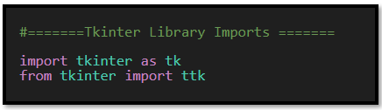

# Start with the same Python file from last week

Instead of starting from scratch here, we could just take the same file that we were working on last week, and then just add the code for the button to our existing code.

**#=======Tkinter Library Imports =======#**

import tkinter as tk

from tkinter import ttk

**# Creating the visiable application window**

root = tk.Tk()

**# Optional: Set window properties**

root.title("My Tkinter Application")  **# Title of the window**

root.geometry("400x300")  **# Set the window size (width x height)**

**# Add widgets and define their layout here**

**# Example:**

label = tk.Label(root, text="FRUITS")

label.pack(pady=20) **# Add some padding**

fruit_label = tk.Label(root, text="Select your favorite fruit:")

fruit_label.pack(pady=2)  **# Add some padding**

fruit_dropdown = ttk.Combobox(root, values=["Apple", "Banana", "Cherry", "Date"])

fruit_dropdown.pack(pady=2)  **# Add some padding**

def update_label(event):

       selected_value = fruit_dropdown.get()

       submit_label.config(text=f"You selected: {selected_value}")

fruit_dropdown.bind("<<ComboboxSelected>>", update_label)

submit_label = tk.Label(root, text="")

submit_label.pack(pady=2)  **# Add some padding**

**# This will show you the window**

root.mainloop()

# Creating the Button

Let’s start with the function that we will use to power up the button. The function will be simple, and we can name this function anything we want. But what we would like our function to do here, is to target the submit_label, which is the same label that we used to show the fruit selection, which you may remember from last week’s lesson, was used by the Combobox.

So, as I have already stated we will want to target that label, and then use the config method on it. We can use the config method because it is available through the library that we brought in with our import statements. So, it is already written, and we do not need to really know what it does, but it will help us in making changes to the text that is in the submit_label.

So, we use that method, and it needs to know that it is working with text, and what that text is supposed to say. So, put two things in the parenthesis, because in order for the config function to do its thing, it needs to know this stuff.

So, here is our function:

**def** on_button_click():

       submit_label.config(text="You clicked the button!")

Now that we have our function, we can create the button.

Build the widget, which is a button. We can name the button anything that we want. But for a button we have to set it to a **tk.Button**. Now what we want to pass to ‘our own version’ of this button is: Where we want it to be placed: **root** (the window), what text we want on the button(**text=”Submit”**), and then we need to call that button that we created in our function(**command=lambda: on_button_click()**).

Lastly we want to make sure we pack the submit button to the screen, if you do not pack it, you will not see it. We can pass a small **padding** to the button through the argument list.

submit_button = tk.Button(root, text="Submit", command=lambda: on_button_click())

submit_button.pack(pady=5)  # Add some padding

Now if you click on Submit button, you will see the label saying **‘You clicked the button!’**

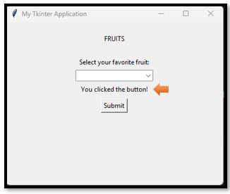

# Now for the Entire Code

**#=======Tkinter Library Imports =======**

import tkinter as tk

from tkinter import ttk

# Creating the visiable application window

root = tk.Tk()

# Optional: Set window properties

root.title("My Tkinter Application")  # Title of the window

root.geometry("400x300")  # Set the window size (width x height)

# Add widgets and define their layout here

# Example:

label = tk.Label(root, text="FRUITS")

label.pack(pady=20) # Add some padding

fruit_label = tk.Label(root, text="Select your favorite fruit:")

fruit_label.pack(pady=2)  # Add some padding

fruit_dropdown = ttk.Combobox(root, values=["Apple", "Banana", "Cherry", "Date"])

fruit_dropdown.pack(pady=2)  # Add some padding

def update_label(event):

       selected_value = fruit_dropdown.get()

       submit_label.config(text=f"You selected: {selected_value}")

fruit_dropdown.bind("<<ComboboxSelected>>", update_label)

submit_label = tk.Label(root, text="")

submit_label.pack(pady=2)  # Add some padding

# Button widget

def on_button_click():

       submit_label.config(text="You clicked the button!")

submit_button = tk.Button(root, text="Submit", height=3, width=18, bg='red', fg='white', command=lambda: on_button_click())

submit_button.pack(pady=5)  # Add some padding

# This will show you the window

root.mainloop()